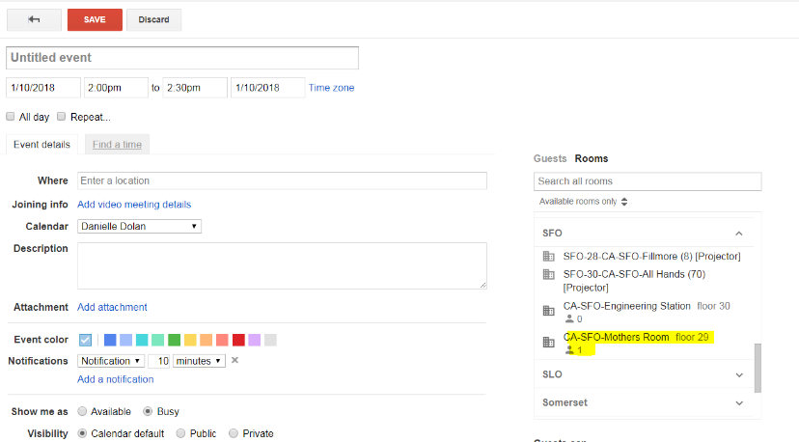
San Francisco Lactation Accommodation Policy – Process Document
Sunrun is in compliance with the San Francisco Lactation in the Workplace Ordinance.
- Lactating employees in the workplace have a private space, the Mother’s Room, located on the 29th floor.
- Employees are entitled to lactation breaks throughout the day. Employees can reserve the Mother’s Room for these breaks.
- The Mother’s Room can be reserved on the Google Calendar (Fig 1) in the same way that a conference room is reserved. This is to ensure that every employee has privacy when using the room.
  - The Mother’s Room is a space that is safe, clean, and free of hazardous materials
  - The Mother’s Room contains a place to sit, a surface to place a breast pump and personal items, and has access to electricity.
- Access to the Mother’s Room can be added to the badge access for the employee. Badge access can be requested through a Remedy Force ticket opened by the employee.
- Sunrun will keep record of who has used the room through the calendar view located within Google Calendars.
Lactation Accommodation Policy
Fig. 1

